Table of Contents

**Ganesh Chaturthi: Honoring the Remover of Obstacles** 2

Introduction: A Festival of Auspicious Beginnings 2

Mythological Origins of Lord Ganesha 3

The Birth of Ganesha 3

Rituals and Practices During Ganesh Chaturthi 3

Installation of Idols (Murti Sthapana) 3

Public Celebrations and Cultural Events 4

Visarjan: Bidding Farewell with Devotion 4

Regional Variations Across India 4

Symbolic and Spiritual Meaning 4

Conclusion: A Joyous Farewell, A Hopeful Return 5

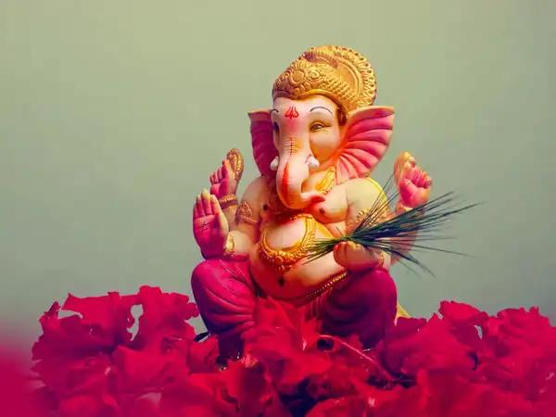

**Ganesh Chaturthi: Honoring the Remover of Obstacles**

## Introduction: A Festival of Auspicious Beginnings

**Ganesh Chaturthi**, also known as **Vinayaka Chaturthi**, is a vibrant and deeply revered Hindu festival that celebrates the **birth of Lord Ganesha**, the elephant-headed god of wisdom, prosperity, and remover of obstacles. Observed during the **Bhadrapada month** (August–September), it is a 10-day festival marked by **devotion, colorful processions, artistic idol installations, and community celebration**. Ganesh Chaturthi brings people together to welcome the beloved **Ganapati Bappa** into their homes and hearts.

## Mythological Origins of Lord Ganesha

### The Birth of Ganesha

According to Hindu mythology, **Goddess Parvati** created Ganesha from sandalwood paste to guard her privacy while she bathed. When **Lord Shiva**, her consort, returned and was denied entry by Ganesha, a battle ensued, resulting in Ganesha’s head being severed. Upon realizing his mistake, Shiva replaced his head with that of an **elephant**, bringing Ganesha back to life and declaring him the **lord of beginnings and remover of obstacles**.

**Other Beliefs**

Some traditions also regard Ganesha as the **scribe of the Mahabharata**, who wrote the epic as **Sage Vyasa** narrated it, symbolizing intelligence and devotion.

## Rituals and Practices During Ganesh Chaturthi

### Installation of Idols (Murti Sthapana)

Devotees install **beautifully crafted clay idols** of Ganesha in homes or public pandals (temporary structures). Prayers (puja), offerings, and decorations are performed with joy and enthusiasm. Each day involves rituals like:

* **Aarti** (devotional songs)
* **Naivedya** (offering sweets, especially modaks – Ganesha’s favorite)
* **Mantra chanting and bhajans**

**Eco-Friendly Celebrations**

In recent years, there’s been a growing emphasis on **eco-friendly Ganesha idols** made from natural clay and organic colors to reduce pollution during idol immersion.

## Public Celebrations and Cultural Events

The public celebration of Ganesh Chaturthi was **popularized by freedom fighter Lokmanya Tilak** in the 1890s to unite people against British rule. Today, **cities like Mumbai, Pune, and Hyderabad** host grand celebrations featuring:

* **Massive Ganesha idols**
* **Dance, music, and drama performances**
* **Social and cultural activities**
* **Community feasts and charitable events**

These festivities strengthen **communal harmony and social unity**.

## Visarjan: Bidding Farewell with Devotion

On the last day (Anant Chaturdashi), the idol is taken in a **grand procession** to be **immersed in a water body (visarjan)**. Devotees chant:

**“Ganapati Bappa Morya, Pudhchya Varshi Lavkar Ya!”**  
(Oh Lord Ganesha, come again soon next year!)

The immersion symbolizes the **cycle of creation and dissolution**, reminding devotees of impermanence and the presence of divinity within.

## Regional Variations Across India

* **Maharashtra**: Home to the grandest Ganesh festivals with elaborately decorated pandals and celebrity events.
* **Goa & Karnataka**: Emphasize family rituals and community feasts.
* **Andhra Pradesh & Tamil Nadu**: Known as **Vinayaka Chavithi**, celebrated with devotion and Vedic rituals.
* **North India**: While less prominent, Ganesh idols are installed in homes and temples, often linked to Diwali preparations.

## Symbolic and Spiritual Meaning

Lord Ganesha symbolizes:

* **Wisdom and intellect** (large head)
* **Listening and patience** (big ears)
* **Humility and groundedness** (elephant form)
* **Balance in life** (one tusk, one broken)
* **Letting go of ego** (small eyes, large stomach)

Ganesh Chaturthi reminds us to **overcome difficulties, embrace knowledge, and begin life’s journeys with faith and clarity**.

## Conclusion: A Joyous Farewell, A Hopeful Return

**Ganesh Chaturthi** is more than a religious celebration — it is a **spiritual, social, and artistic festival** that fosters unity, devotion, and environmental awareness. As Lord Ganesha returns to his heavenly abode, he leaves behind a renewed spirit of **hope, wisdom, and strength** among his devotees. With chants and celebrations, we say farewell not in sorrow, but in anticipation of his return — ready to **guide us again through life’s obstacles with his divine blessings**.